Final Project –**SeatingPriceChartProgram**

**Project Overview:**

In the final project, you will use what you learn in the course to build a program to manipulate an airplane seating-price chart. It is a small plane with 6-row and 4-column seats.

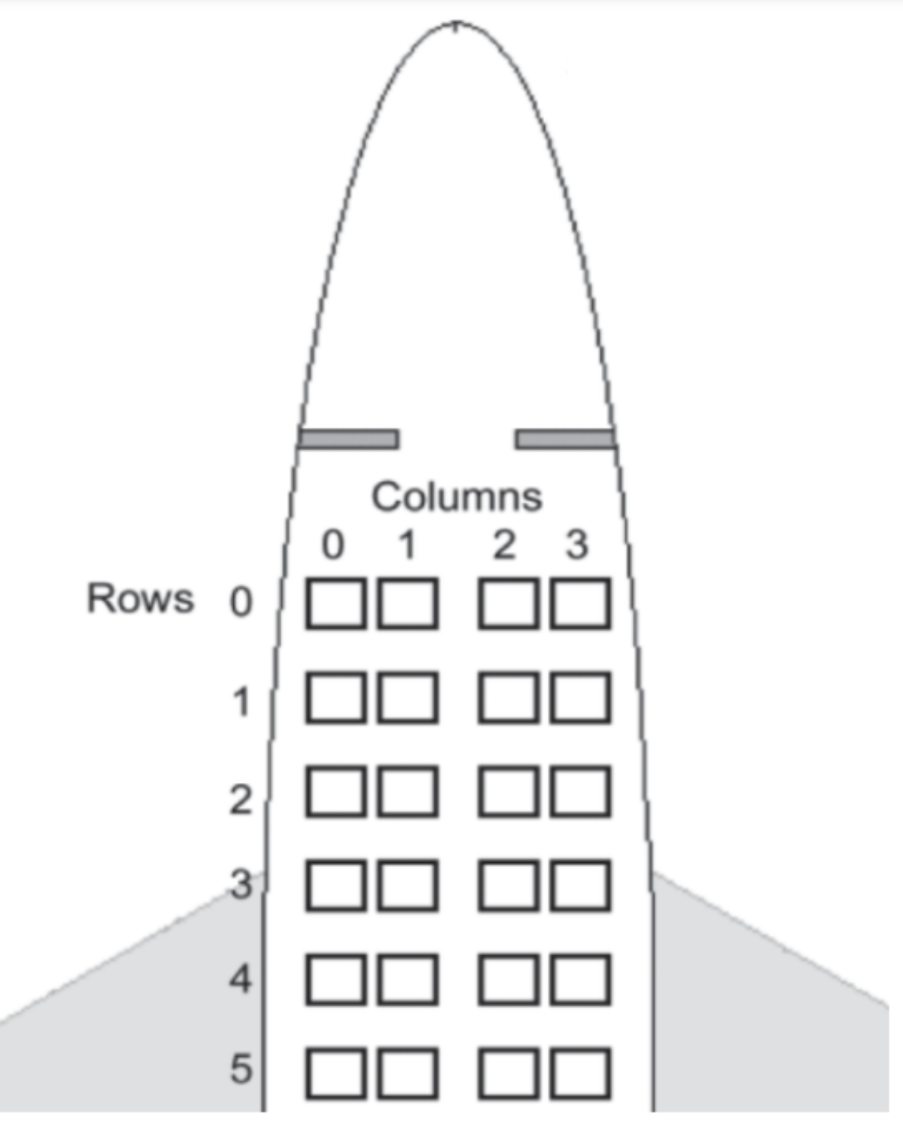

The following concepts and skills should be used in the program

* Functions
* For statements
* If statements
* Constant Variables
* Random module
* F-strings
* etc.

**Requirements:**

1. In the project, you will build the Seating-price Chart Program to
2. create a list of lists Seating-Price (range between $500 and $1000) chart by using the **Random** module
3. display the seating-price chart,
4. find and display the highest price
5. find and display the lowest price
6. calculate the average price and display it,
7. Find ALL seats (row and column) that have the lowest Price and display them
8. Find ALL seats (row and column) that have the highest Price and display them
9. Find a seat (row and column) based on the price entered by users and display the seats information (row & column) you found
10. The user interface looks like below:

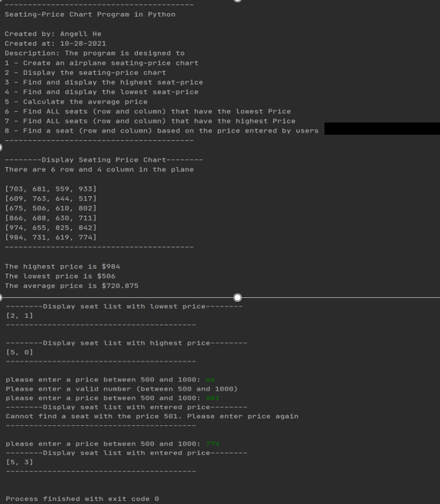

1. The following functions should be created in the program:

def display_title()

1. Parameters: no
2. Return value: no
3. the application title should be displayed like
4. 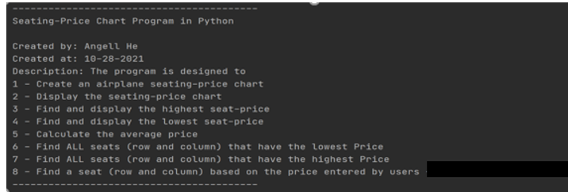

def create_seating_price_chart(row_number, col_number):

1. Parameters: row number, col_number
2. Return value: list of lists – seating_price_chart
3. Note: generate a random number and assign it to a seat price



def display_seating_price_chart(chart_2d):

1. Parameters: chart_2d (seating_price_chart)
2. Return value: no
3. The result should be displayed like below

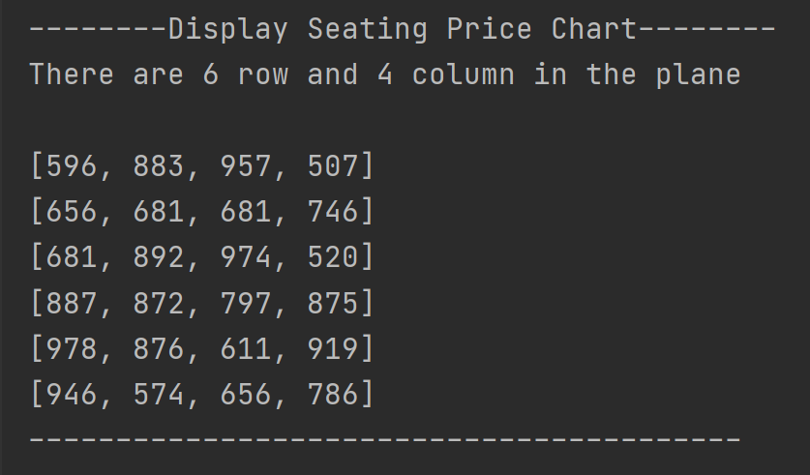

def find_max_value(chart_2d):

1. Parameters: chart_2d (seating_price_chart)
2. Return value: the max value
3. Note:

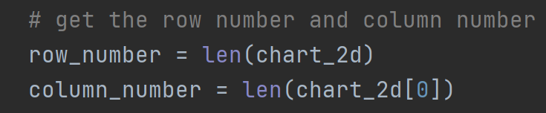

def find_min_value(chart_2d):

1. Parameters: chart_2d (seating_price_chart)
2. Return value: the min value
3. Note:



def calculate_average_price(chart_2d):

1. Parameters: chart_2d (seating_price_chart)
2. Return value: the average value
3. Note:



def find_seats_with_price(chart_2d, price):

1. Parameters: chart_2d (seating_price_chart),

price (the price you are looking for)

1. Return value: the seat list (with the given price)
2. Note:



def display_seat_list(seat_list):

1. Parameters: seat_list (including row and column)
2. Return value: no

**Note:**

1. The project should be done by using **PyCharm**
2. You need to check each task and capture screenshots for recording the test results.
3. Upload the source file (.py) and screenshots to Canvas for grading.